Digital Signage

Jared Miller

Darien Clay

# Table Of Contents

**Table Of Contents** **2**

**Overview of Project** **3**

Project Scope 3

Assumptions and Constraints 3

Summary of Project Deliverables 3

Summary of Schedule and Budget 4

**References** **4**

**Project Organization** **5**

Internal Project Structure 5

Roles and Responsibilities of Members 5

**Technical Process Plan** **6**

Details of Process Model 6

Software Design Methods, Tools, Techniques 6

Development Environment/Infrastructure Establishment Plan 6

**Managerial Process Plans** **7**

Work Plans 7

Work Activities 7

Detailed Schedule 7

Detailed Resource Allocation 7

Control Plans 8

Risk Management Plan 8

Requirements Management Plan 8

Schedule Control Plan 8

Budget Control Plan 8

Quality Control Plan 8

**Supporting Process Plans** **9**

Configuration Management Plan 9

Verification and Validation Plan 9

Reviews and Audits 9

Quality Assurance Plan 9

**Appendices** **10**

Class Diagram 10

Function Point Analysis 11

COCOMO Analysis 11

# Overview of Project

## Project Scope

*To develop a system for the display of signage facilitated by cheap, light, low-power hardware.*

1. Develop a system targeted at the Raspberry Pi 3 platform, with HDMI output to standard television units, capable of the dynamic display of user defined content including text, images, videos/animations, and data streams (weather, RSS, etc).
2. Develop a system targeted at a generic user desktop platform (Windows/Linux/Mac) with the ability to create templates, content and scheduling for deployment to systems as defined in (1), and the ability to manage other aspects of signs, esp. TV on/off schedule.

## Assumptions and Constraints

1. Target player platform availability (Raspberry Pi 3) with the following capabilities
   1. Wireless connectivity over 802.11, with WPA2 PSK/PEAP/etc
   2. Standard HDMI output to TV
   3. Ability to render content, up to videos at 1080p quality with no discernible latency
   4. Access to power at display site
2. Availability of central “Command and Control” server/desktop with the following capabilities
   1. Communication to client over wireless/local wired connection
   2. Communication only required during deployment, players independant
   3. HTML interface with organization defined access control

## Summary of Project Deliverables

1. An image writable to the OS medium for a Raspberry Pi 3 (MicroSD)
   1. Has a separate partition containing configuration info (esp network info)
2. An application server for client creation of templates, schedules, content, feeds, sign configuration
3. Documentation for client deployment configuration

## 

## 

## Summary of Schedule and Budget

* 2-4 Development kits: $1000
  + RPi 3 and kit (power, case, card): $60
  + TV: $100-200
* Computers for 5 persons: $5000
* Facilities: Budget $25,000
  + Nearby space: [$15,000](http://www.loopnet.com/Listing/1047-1085-Professional-Dr-Flint-MI/9840692/)
* Labor: $0.25M (COCOMO)
* Servers: $1000

Total Estimated Budget: $300,000

Estimated Schedule: 10 months

# 

# References

Space costs

<http://www.loopnet.com/Listing/1047-1085-Professional-Dr-Flint-MI/9840692/>

Labor rates for developers

<https://www.bls.gov/ooh/computer-and-information-technology/web-developers.htm>

Development kit costs

<http://www.newark.com/raspberry-pi/raspberrypi3-modb-1gb/sbc-raspberry-pi-3-mod-b-1gb-ram/dp/77Y6520?src=raspberrypi>

# Project Organization

## Internal Project Structure

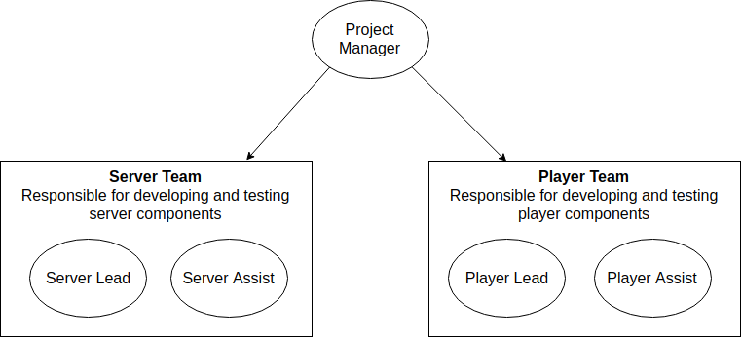

## Roles and Responsibilities of Members

* PM is responsible for overall organization, scheduling, budgeting
* Server lead and assist are the “pair programmers” responsible for designing, implementing and testing the server component.
* Likewise, player lead and assist fulfill the same roles with respect to the player

# 

# 

# Technical Process Plan

## Details of Process Model

Implement XP

## Software Design Methods, Tools, Techniques

Team is recommended to use standard UML mechanisms for the design of the software.

## Development Environment/Infrastructure Establishment Plan

1. Acquire server to house repositories
2. Establish a network
3. Setup credentials for team on servers
4. Install version control software on team computers (e.g. git)
5. Install runtimes for product on team computers
6. Install runtimes on test player hardware

# Managerial Process Plans

## 

## Work Plans

### Work Activities

For each increment:

While features remain to be implemented:

Assign a feature to an appropriate team

### Detailed Schedule

See MS-Project file

### Detailed Resource Allocation

Each member is assigned

* A development computer
* Access to prototype systems
* Access to source control
* Workspace

## 

## 

## Control Plans

### Risk Management Plan

* Have backups of data
* Have extra computers
* Make sure someone is on call to fix the tv’s if there’s an issue

### Requirements Management Plan

* We will make sure we have all of the requirements we need

### Schedule Control Plan

* Start and end time for looped content are accurate
* We have what they want ready

### Budget Control Plan

* Make sure inventory is kept to a set limit
* Workers end shift on time

### Quality Control Plan

Statistics about the development cycle will be gathered, including the following

* Cycle time
* Volume of code per function point
* Time spent on various activities (planning, design, construction, testing, debugging)
* Test pass rate

### 

# Supporting Process Plans

## Configuration Management Plan

* In the planning phase we will have all of the test cases and tools we will need

## Verification and Validation Plan

* In the design phase we will check with the company if that’s how they want their ad to look on the tv

## Reviews and Audits

* When we code the advertisement to display we will review it to make sure everything is there

## Quality Assurance Plan

* We will make sure it is secure and constantly check for security threats so no one can mess with their ad

# Appendices

## Class Diagram

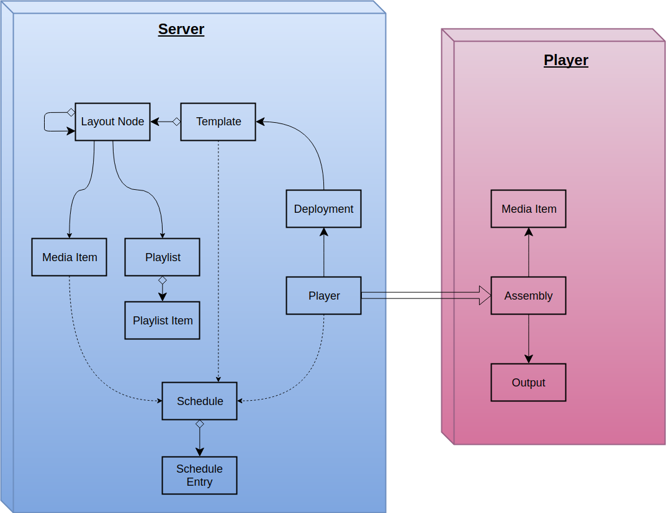

## 

## 

## Function Point Analysis

Server Function Points

| **Input** | **Output** | **File** | **Interface** | **Query** |
| --- | --- | --- | --- | --- |
| HTTP | Assembly | Database | media | media CRUD |
|  | SSH Connection | Media | player | player CRUD |
|  |  |  | template | template CRUD |
|  |  |  | playlist | playlist CRUD |
|  |  |  | schedule | schedule CRUD |

Player Function Points

| **Input** | **Output** | **File** | **Interface** | **Query** |
| --- | --- | --- | --- | --- |
| Assembly | Screen | Media File |  |  |
| Configuration |  |  |  |  |

## COCOMO Analysis

